PREREQUISTIES:

IBM IOT CLOUD CREATION:

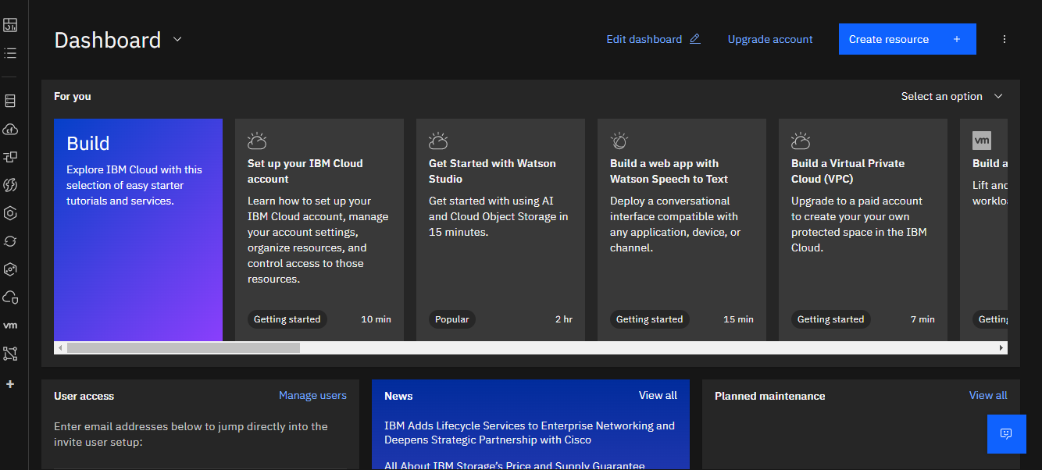

SOFTWARE:

